ASSESSMENT DECLARATION COVER SHEET
Please complete this cover sheet for each assessment submission. For group assessments, each group member must individually complete and submit a cover sheet.
STUDENT (REGISTRATION) NUMBER: Click or tap here to enter text.
MODULE TITLE: Click or tap here to enter text.
DATE OF SUBMISSION: Click or tap to enter a date.
I declare that, except where explicitly acknowledged*, this assessment is my own work and has not been submitted for any other module or degree programme at Edinburgh Napier University or any other institution. This declaration is made in compliance with Edinburgh Napier University’s Academic Integrity Regulations.
*IMPORTANT: Contributions from other sources include incorrectly cited quotations or content generated by Generative Artificial Intelligence (Gen AI) tools, such as ChatGPT. See Artificial Intelligence Tools and Your Learning for more information.
Note: Unless stated in the Assessment Brief, use of Grammarly for checking spelling and grammar is allowable in this assessment, but it cannot be used to generate content.
Please declare here your use of such tools in this assessment submission:
(Select one of the two options below)
☐ | Yes, I have used Gen AI tools for this submission and I have described how below.
☐ | No, I have not used Gen AI tools for this submission.
If you selected Yes, briefly describe (in less than 100 words) how you used these tools:
Click or tap here to enter text.

Module Leader:
Student name:
Student ID:
Topic: Digital Transformation and Competitive Strategy in the UK Logistics Industry: A Case Study of GXO Logistics in the United Kingdom
Word count: 8119

Executive Summary
The UK logistics industry experiences revolutionary changes associated with the development of such areas as e-commerce, labor shortage, increasing customer demands, sustainability, and technology advances. The adoption of digitalization, automation, artificial intelligence (AI), robotics, and big data become more widespread in logistics operations. The UK transport and storage industry has created a GVA of over £67.8 billion proving the importance of the industry for the economy. In this connection, the company GXO Logistics UK gains the competitive advantage through warehouse automation, AI, predictive analytics, and digitalization of the supply chain. Thus, the aim of this research is the investigation of the company's response to the changes in the industry and the role of digitalization in gaining the competitive advantage. The following research goals have been defined: identification of the operational impact of disruptive technologies in the document, analysis of digital capabilities of the company and their contribution to the competitive advantage and growth, comparison of digitalization process at GXO with those of other companies in the industry and development of recommendations for the competitive advantage acquisition through digitalization.
A qualitative case study design has been utilised while targeting GXO logistics UK. Secondary data has been gathered from GXO annual reports which had the investor data, government as well as other industry reports, Statista, Reuters and other peer reviewed articles. Followed by Thematic analysis to evaluate automation, digital capabilities and competitive positioning with innovation and strategic change. The data has been evaluated with the help of Dynamic Capabilities Theory with porters Five Forces for assessing not only the organisational capabilities but also competitive factors. The findings on the other hand hints towards the automation, AI optimisation for productivity, speed and accuracy so that manual work could be reduced. GXO utilised autonomous mobile robots and collaborative robotics with automated sortation along with goods to person systems. In contrast, automation calls for higher investment with employee involvement which calls for changes in attitudes of the employees. Hence technology acts as the driving force instead of a direct source of competitive advantage.
The company possesses certain digital capabilities including automation, predictive analytics, machine learning, and GXO IQ AI-first platform. The value of GXO technology and automated systems property and equipment amounted to approximately $582 million in 2025 compared to $531 million in 2024. Nevertheless, the analysis of the competitors shows that the company operates in a technology intensive environment. Thus, the company cannot rely on its possession of the technology to gain the competitive advantage; it should integrate the technology into the data, employees, operations, and customers.
Thus, the research recommends that GXO should integrate AI and operational data, pay attention to the automation with returns in mind, focus on digital differentiation from the customers' perspective, develop the digital capabilities of employees and create integrated capabilities difficult to replicate by competitors. In the short-term period, GXO should pay attention to the AI and data integration and employees' training, in the medium-term period – automate the processes and create the customer-facing digital platform, and in the long-term period – create proprietary data-based capabilities and innovations.

Table of Contents
CHAPTER 1: INTRODUCTION 8
1.1 Introduction 8
1.2 Background UK Logistics Industry 8
1.2 Company Background: GXO Logistics UK 9
1.3 Research Problem 10
1.4 Research Aim and Objectives 10
1.5 Research Significance 11
1.6 Structure of the project 12
CHAPTER 2: LITERATURE REVIEW 13
2.1 Introduction 13
2.2 UK Logistics Industry Trends 13
2.3 Theoretical Foundation 16
2.4 GXO Logistics UK's Competitive Capabilities 21
2.5 Competitor Analysis Literature 23
2.6 Conceptual Framework 24
2.7 Literature Gap 26
2.8 Chapter Summary 26
Chapter 3: RESEARCH METHOD, ETHICAL IMPLICATIONS 27
3.1 Introduction 27
3.2 Research Design and Research Strategy 27
3.3 Secondary Data Collection 27
3.4 Data Analysis Method 28
3.5 Ethical Considerations 29
3.6 Research Limitations 29
Chapter 4: CASE STUDY & ANALYSIS 30
4.1 Introduction 30
4.2 Documented Operational Effects of Disruptive Technologies in UK Logistics 30
4.2.1 Automation and Robotics 30
4.2.2 Artificial Intelligence and Predictive Analytics 30
4.2.3 Documented Benefits and Costs of Automation 31
4.2.4 Critical Evaluation 32
4.3 GXO Logistics UK's Digital Investments and Capabilities 32
4.3.1 GXO's Digital Technology Investments 32
4.3.2 AI, Data and Digital Supply-Chain Capabilities 32
4.3.3 Application of Dynamic Capabilities Theory 33
4.3.4 Application of Resource-Based View 33
4.4 Comparative Analysis of GXO Logistics UK and Industry Competitors 34
4.4.1 GXO vs DHL Supply Chain 34
4.4.2 GXO vs Kuehne+Nagel and CEVA Logistics 34
4.4.3 Competitor Positioning 35
4.4.4 Application of Porter's Five Forces 36
4.5 GXO's Competitive Strategy and Competitive Advantage 36
4.5.1 Application of Porter's Generic Strategies 36
4.5.2 Digital Transformation → Competitive Advantage 37
4.6 Key Findings and Strategic Implications 37
Chapter 5: CONCLUSION & RECOMMENDATIONS 39
5.1 Introduction 39
5.2 Overall Conclusion 39
5.3 Conclusions Against Research Objectives 39
5.4 Recommendations for GXO Logistics UK 41
5.5 Implementation Priorities 42
5.6 Future Research 43
References 44
Appendix 56
Appendix A – Study Summary Table 56
Appendix B – Secondary Data Extraction Matrix 57
Appendix C – Search Strategy 58
Appendix D – Thematic Coding Framework 59
Appendix E – Competitor Benchmarking Data 60
Appendix F – Evidence Triangulation Matrix 61

CHAPTER 1: INTRODUCTION

1.1 Introduction
The logistics sector in the UK is supposed to be viewed as one of the major sectors in the economy of the country and in the world since it is responsible for the delivery and distribution of goods through the supply chain. There have been many changes in the logistics sector due to innovations like digitalization, automation, artificial intelligence (AI), robotics, and data analytics over recent years. Furthermore, the development of e-commerce, necessity of fast delivery, environmental issues, and lack of labour force increase the level of competition in the industry. The above factors result in development of innovative business models and application of innovations in order to increase the competitiveness of companies within the logistics industry.
It is possible to speak about GXO Logistics UK as an example of the logistics company which spends much money on the automation of the warehouse, artificial intelligence, and digitalization of the supply chain in order to increase the efficiency of its activities. Nevertheless, GXO Logistics UK faces strong competition from other logistics companies using innovations in their business activities. In the past, the digital transformation of the logistics company and the competitive strategy of the company were viewed as separate spheres, but there is no information about the effect of the digital transformation on the competitive strategy of the company in connection with the increasing logistics industry in the UK. Thus, the main aim of the research is the study of competitive strategy, digital capabilities of GXO Logistics UK, and their effect on competitive advantage and market growth.

1.2 Background UK Logistics Industry
The logistics industry in the UK is an integral element of the economic structure of the country providing services for domestic and international trade and logistics for the supply chain in such industries as retailing, manufacturing, healthcare, and eCommerce. According to the Department for Transport (2024) the transport and storage industry produced over £67.8 billion of GVA in the economy of the UK. Moreover, the service industry of the country including the household consumption (which is 60% of the UKs GDP) requires effective logistics services to work efficiently and satisfy its customers' needs (Office for National Statistics, 2024).
In addition to that, logistics industry in the UK undergoes significant changes due to the processes of recovery from the pandemic as well as change in demands, expectations, and preferences of its customers because of the growing role of eCommerce, innovative technologies, and their implementation (Alkaraan et al., 2023). Nowadays, the UK is one of the leaders in terms of eCommerce in Europe with the share of eCommerce constitutes 26-27% of total retail sales in 2024. As a result, there appears a greater demand for order fulfilment and inventory management requiring the logistics companies to implement robots, artificial intelligence, and IoT solutions to increase the efficiency of the logistics and supply chain transparency (Clarke et al., 2023).
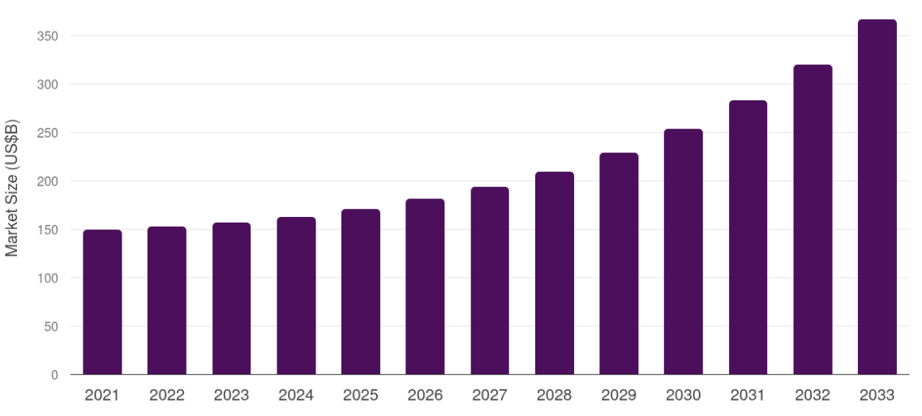
Figure 1: UK Logistics Industry Overview
(Source: Grand View Research, 2024)

1.2 Company Background: GXO Logistics UK
GXO Logistics, has been segregated and later it turned to XPO Logistics since 2021, and it turned out to be the main corporations offering pure-play contract logistics services, that concluded warehousing, e-commerce fulfillment, reverse logistics, transportation management, accompanied by supply chain optimization worldwide. In 2024, GXO had 152,000 sheltered in 1,030 warehouses with 218 million square feet (GXO Logistics, Inc., 2025). Another major country for GXO Logistics is the UK, which has a highly-developed e-commerce industry, with complicated retail supply chains in technology-driven logistics services. As per Competition and Markets Authority (2024) GXO enhanced its presence in the UK after it bought Wincanton plc. for £762 million. This transaction assisted the company in gaining new competences in warehousing, transport, and digital logistics services offered in the UK and Ireland. GXO Logistics UK has been facing serious challenges which are related to innovation, customers' demands, sustainability requirements, as well as strong competition in the sphere, hence, GXO need to make investments in innovations and flexibility.

1.3 Research Problem
One of the major challenges discussed in this paper is the ability of GXO Logistics UK to exploit its competitive advantages during the era of digitalization that became an important feature of the logistics sector in the UK. Indeed, such technologies as artificial intelligence, robots in warehouses, automation, and other technologies have become common for logistics operations in the leading companies. Nevertheless, increasing consumer expectations concerning fast and sustainable logistics services required innovating (Zhao et al., 2023). Thus, the process of implementing digital technologies into the operations of GXO Logistics UK has been undertaken; however, these technologies were used simultaneously by its main competitors such as DHL Supply Chain, Kuehne+Nagel, and CEVA Logistics. Therefore, it has become harder for GXO Logistics UK to compete with its rivals and maintain its market positions. Though digitalization and innovation in logistics have been examined separately, few studies exist on the connection between digitalization competences of GXO Logistics UK and its competitive advantage compared to UK competitors.

1.4 Research Aim and Objectives
Aim:
To study how GXO Logistics UK is growing and adapting to changes in the UK logistics market, and to suggest ways it can stay competitive.
Objectives:
- To evaluate the documented operational effects of disruptive technology particularly automation, within the UK logistics industry.
- To assess the digital capabilities of GXO Logistics UK paired with their contribution to attain competitive advantage along with growth.
- To compare digital capabilities and transformation of GXO Logistics UK with their competitors in the logistics industry.
- To suggest measures that will allow GXO Logistics UK to achieve competitive advantage through digital transformation.

1.5 Research Significance
The significance of research is connected with the fact that the research is going to contribute to the literature on logistics management where market trends, competitive positioning and digitization are studied jointly. Even though there were several research papers devoted to automation, sustainability, and resilience of supply chains, none of these papers provided critical analysis of the influence of these issues on the competitive growth of one of the leading contract logistics companies in the UK.
From the viewpoint of management, the results of the study will be useful for finding out the strengths and weaknesses of GXO Logistics UK regarding its response to the market changes, namely automation, artificial intelligence, labor shortage and high expectations of customers. The information received in the course of the research can be used in order to make decisions about technological development and innovative competitive strategy of the company. Practically speaking, the research will be valuable for the whole logistics industry in the UK since it will show good practices of efficiency, value creation and competitive advantage.

1.6 Structure of the project
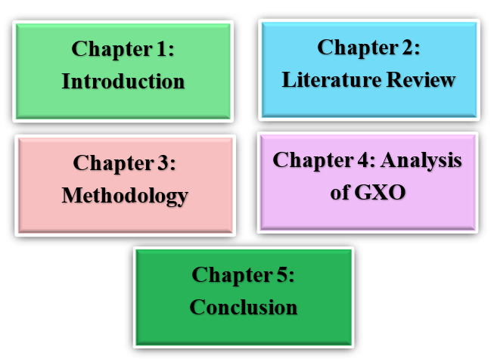
Figure 2: Structure of the project
(Source: Self-created)
The research project has been divided into five chapters. The first chapter is structured with research background, research problem, research objective, and purpose of research. The second chapter reviews the contemporary literature which is present on the chosen topic. The third chapter revolves around the research methodology along with the fourth chapter which would discuss the competitive positioning of GXO Logistics UK, and then the research concludes with a conclusion and recommendation.

CHAPTER 2: LITERATURE REVIEW

2.1 Introduction
This chapter reviews the contemporary literature which is available for the topic of strategic adaptation and positioning of GXO Logistics UK in the ever-changing logistics market in the UK. It is expected that this chapter will serve as a good theoretical basis for the research, as it will conduct the critical analysis of the literature published between 2020 and 2025, related to the discussed issues of the logistics market trends, competitive strategy, digitization and organizational capabilities. Moreover, different strategic management theories will be critically analysed for their capability of explaining competitive advantages of logistics organizations.

2.2 UK Logistics Industry Trends
It has to be admitted that logistics in the UK has experienced certain transformations over the last years due to the fast technological development, changes in consumer behaviour, environmental sustainability, labor shortages, and economic instability. Being one of the largest logistics markets in Europe, logistics has become very important for proper functioning of the supply chain, international business, and e-commerce in the country. As it follows from the information provided by Logistics UK (2025), the annual contribution of the UK freight and logistics industry to the national economy makes £170 billion while about 7 million people find employment due to the activity of the said sector in the country.
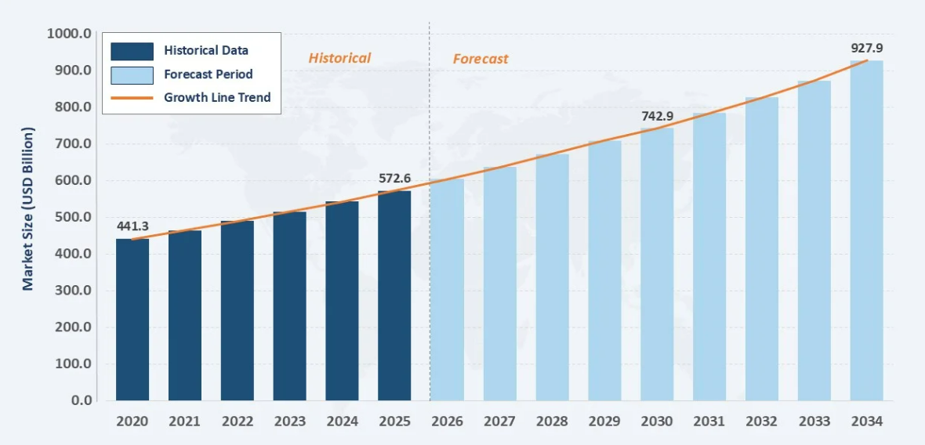
Figure 3: Major Trends Transforming UK Logistics
(Source: IMARC Group, 2026)
Rapid expansion of e-commerce
The second trend which impacts logistics providers is the immediate development of e-commerce. The pandemic has become the reason for the emergence of online shopping. According to the data provided by John et al. (2023), the share of internet retail sales in the total retail sales in the UK is rather high and requires the provision of fast delivery and flexible solutions for fulfilment and delivery. However, researchers note that growing demands of customers in terms of same-day and next-day deliveries lead to the increase in the cost of logistics operations (Song et al., 2024).
Environmental sustainability
The third trend influencing the logistics strategy of the company is connected with environmental sustainability. The aim of the UK Government to achieve net zero greenhouse gas emissions by 2050 has stimulated the adoption of green supply chains by logistics companies. In addition to this, customers accompanied by investors showcase their interest in high ESG performance of logistics companies. Various researchers asserted that the capital-intensive character of fleet electrification with low-carbon technologies enables financial problems in terms of financial stability.
Digital transformation
Digital transformation could be defined as the implementation of new technologies such as AI, automated warehousing, robotics and so on underwent several significant changes which are related with inventory management, route optimization. Parcel Perform (2025) showcased that digital technology has the potential which allows cost reduction that is associated with logistics by at least 15% thus helping them to provide customer service. However, Verma (2026) depicted adopting such new technologies could become very costly for the smaller organizations.
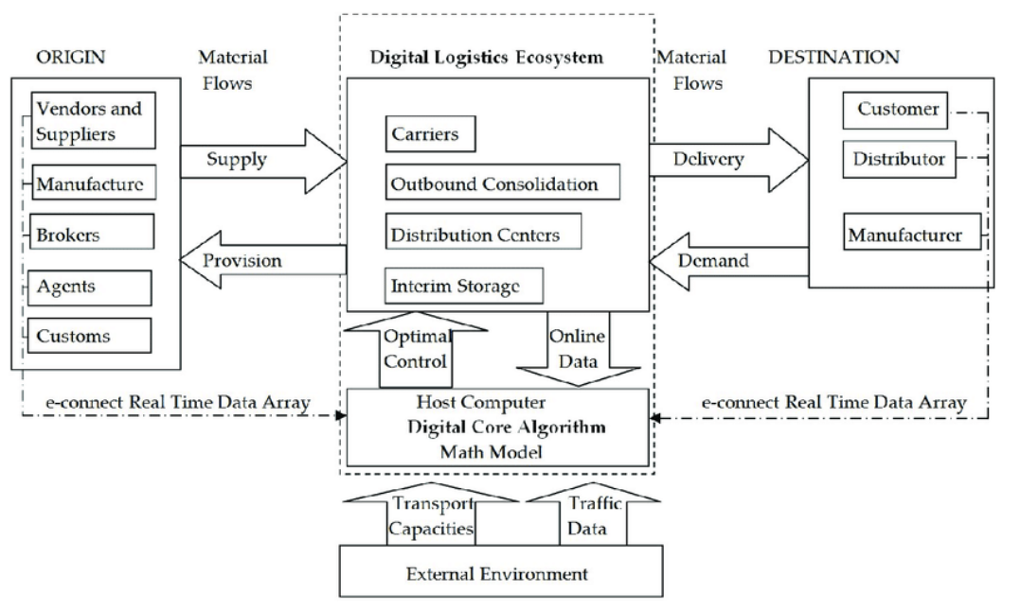
Figure 4: Digital Logistics Ecosystem
(Source: Barykin et al., 2020)
Labour shortages and rising operational costs
Finally, there is the problem of persisting labor shortages and rising operational costs. According to Hopkins et al. (2024), there is the lack of HGV drivers, warehouse operatives, and digital specialists that affects the quality of services and supply chain resilience. It is to be noted that this led to increased investment in automation while helping the robots in overcoming the labour shortages. In contrast, the researchers argued that automation needs to support human workers as the technology still needs to be professional for managing, and maintaining (Masriadi et al., 2023).

2.3 Theoretical Foundation
Dynamic Capabilities Theory
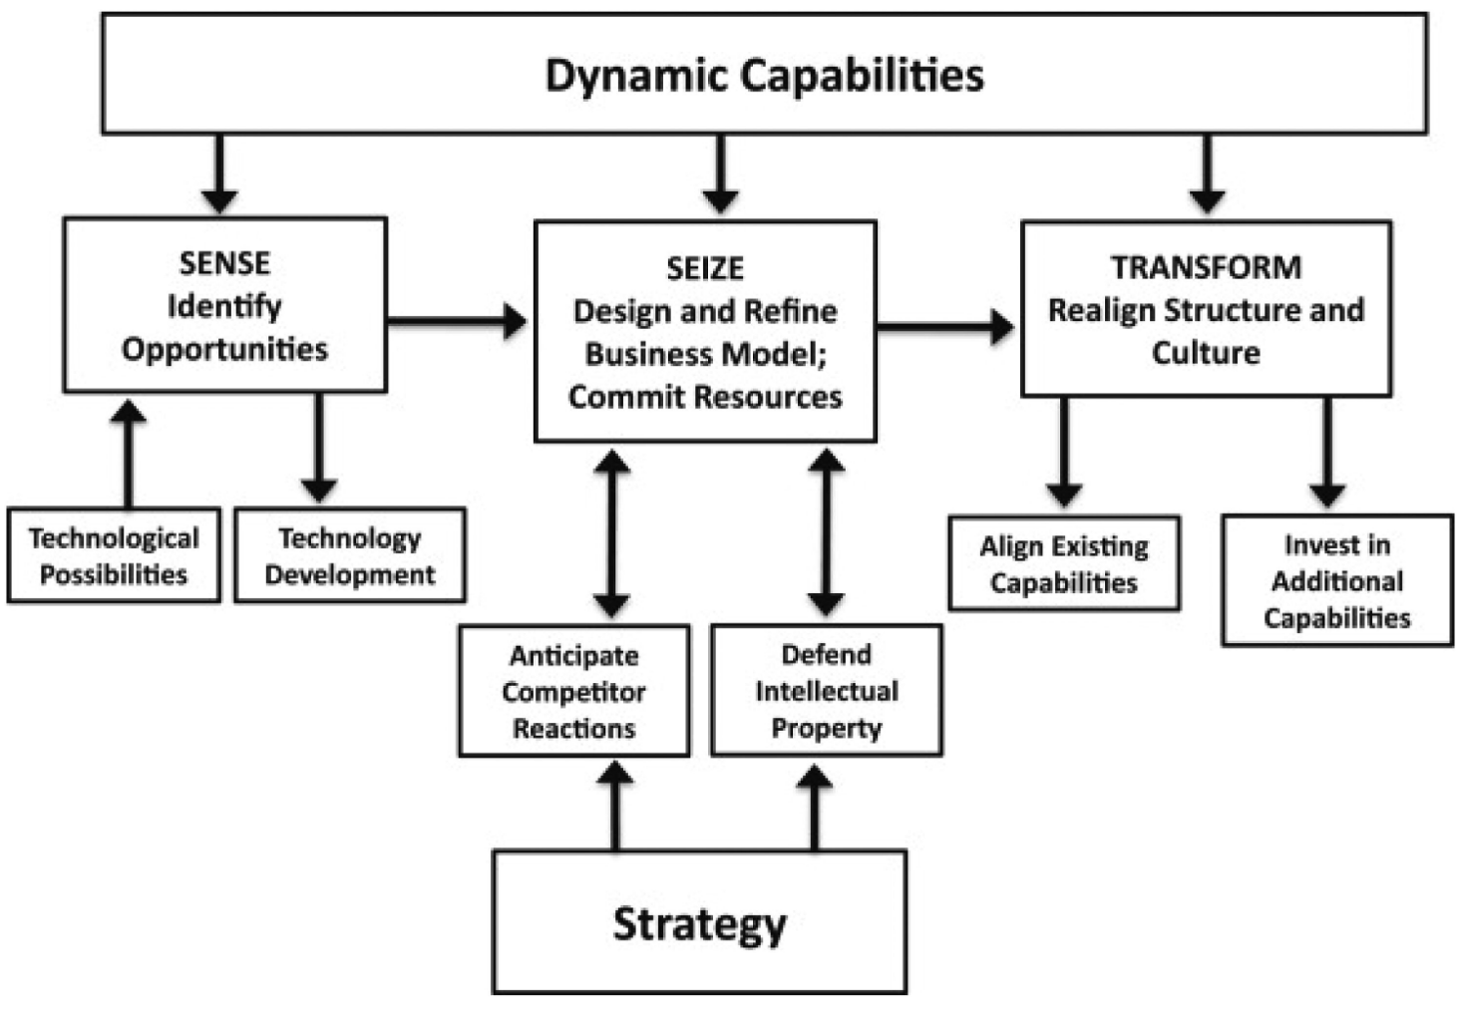
Figure 5: Dynamic Capabilities Theory
(Source: Shiferaw & Amentie Kero 2024)
The Dynamic Capabilities Theory (DC), as explained by Brewis et al. (2023), is the ability of an organization to gain competitive advantages by being aware of any changes in its environment, exploiting opportunities, and transforming its resources within the organization. According to Al Humdan (2026), the idea of dynamic capabilities has already moved past operational agility and become the "hyper-agility" of the firm that allows it to adapt to such issues as coronavirus, geopolitics, and technological disruptions.
For improving the operations and giving better services, GXO Logistics UK has taken up many significant efforts for automating the work process in the warehouse through the implementation of robotics and artificial intelligence. It demonstrates capability transformation rather than simple resource utilization in the new context. Nevertheless, according to the criticism of the theory, there is a lack of sufficient information on how organizations could measure and develop their dynamic capabilities.
Resource-Based View (RBV)
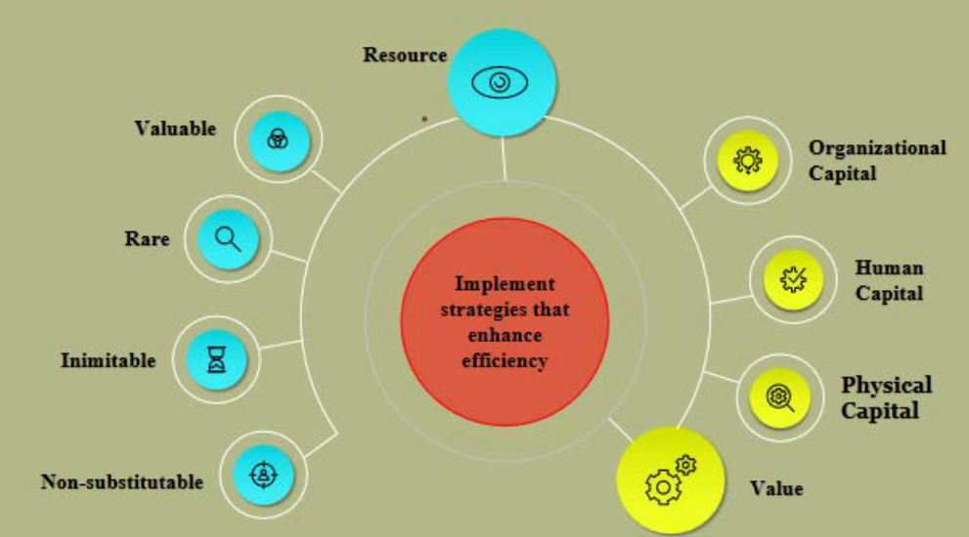
Figure 6: Resource-Based View (RBV)
(Source: Rishi et al., 2022)
The basis of competitive advantage under the resource-based view theory relies on the value, rarity, inimitability and non-substitutability of resources (VRIN). There are three types of traditional resources: physical resources, financial resources and human capital. In addition, nowadays researchers develop the resource-based view theory in accordance with its connection with digital transformation and Industry 4.0 technologies. According to Huang et al. (2023), intangible resources like advanced analytics, Internet of Things, cloud computing and supply chain visibility can increase resilience of an organization through dynamic capabilities. Instead of taking technology as one of the sources of competitive advantage, the author emphasizes the significance of correct integration of digital resources and organizational capabilities.
Strategic resources of GXO Logistics UK are networks of warehouses and fulfilment centres, good relationships with customers, competent personnel and digital logistics platform. However, the resource-based view theory is criticized because valuable resources do not guarantee competitive advantage. Technologies used by the firm can be easily copied by another company in case of constant changes in the market environment. Therefore, RBV should be complemented by the theory of dynamic capabilities.

Porter's Generic Strategies
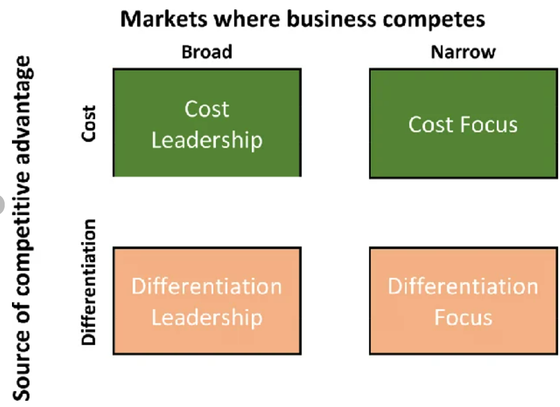
Figure 7: Porter's Generic Strategies
(Source: Nanyangwe et al., 2021)
Porter (1985), suggested that the competitive advantage comes from cost cost leadership, differentiation, or focus strategies. But though this framework is very popular, the current literature studies upon logistics depicts more and more hybrid approaches which comprises both cost efficiency and innovation. Cost leadership in the UK logistics industry has been achieved due to automation, optimization of warehouse processes, along with economies of scale. Differentiation has become possible due to customization of logistics solutions, transparency within supply chain, sustainability factors, and services to the customers.
The main strategic approach which is adopted by GXO Logistics UK is differentiation with the help of technology-based contract logistics solutions rather than utilising cost advantage. However, the approach which is followed by Porter's has been criticized as it assumes the usage of at least one generic strategy by the company.
Porter's Five Forces
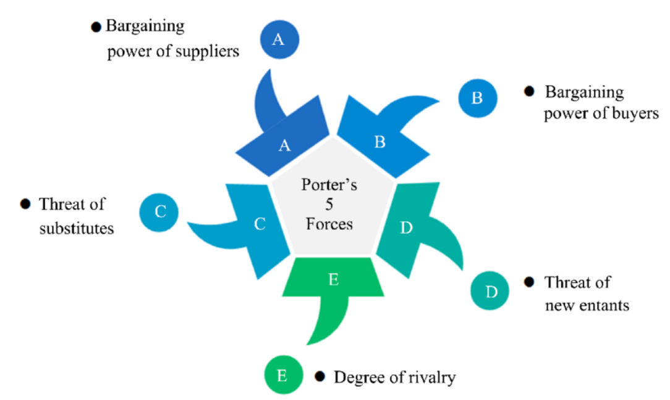
Figure 8: Porter's Five Forces
(Source: Mao, 2023)
Porter’s Five Forces framework is a framework which is aimed at evaluating the factors including competitor rivalry, bargaining power of buyers, bargaining power of suppliers, threat of new entrants and threat of substitutes. There are various rivals in the market including DHL Supply Chain, Kuehne + Nagel, CEVA Logistics, DSV, and Wincanton. But in contrast, competitive forces in the industry include limited labor, too much operational costs with sustainable demands.
Moreover, the Dynamic Capabilities Theory totally revolves around organizational change, the Resource Based View reveals about strategic resources, Generic Strategies study the ways to attain competitive advantage, whereas Porter's Five Forces offers an external perspective in terms of competition. These perspectives enable conducting analysis of how GXO Logistics UK could attain its competitive advantage while making sure that its sustainable development in the UK.

2.4 GXO Logistics UK's Competitive Capabilities
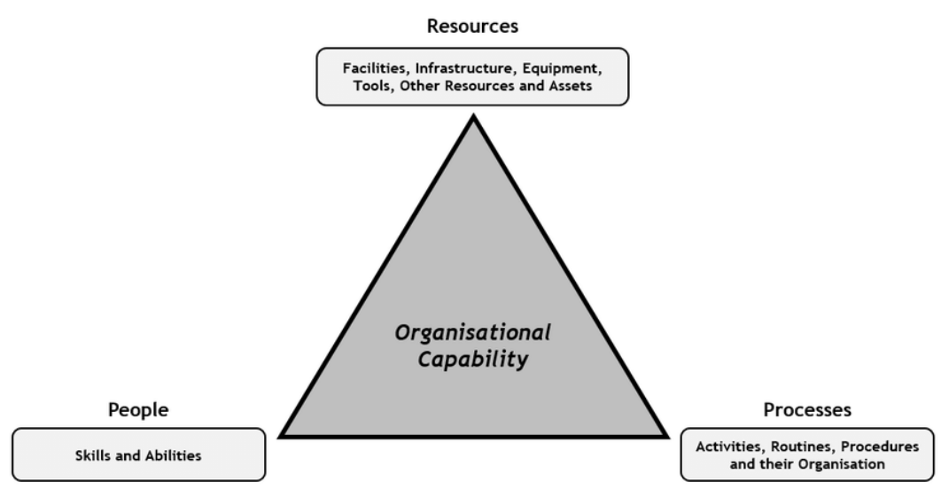
Figure 9: GXO Competitive Capability Framework
(Source: Jacobs et al., 2020)
There were many transformations in the logistics sector after 2020 due to innovation, disruptions in the supply chain, labour shortage, and rising demands of customers. In this respect, the competitive advantage cannot be acquired due to the ownership of transportation and warehouse facilities. Research shows that the operational excellence, digital capability, innovation, customer engagement, and flexibility of the organization are the main capabilities influencing competitiveness in the logistics industry (Minh et al., 2024).
Operational excellence is one of the primary competencies in the case of a logistics company nowadays. According to Al Zadajali & Ullah (2024), logistics firms that constantly manage to improve efficiency in their warehousing processes, accuracy of inventories, and reliability in their transportation activities will have more chances to retain their clients and gain long-term cost advantages. In contrast to this, several researchers asserted that the utilisation of automated technologies in excess might result in limited organisational flexibility as they might require considerable financial investment (Hayton, 2023).
The digital capability is considered to be one of the most important competitive capabilities in the logistics industry. Technologies of the Fourth Industrial Revolution such as artificial intelligence (AI), Internet of Things (IoT), cloud computing and warehouse management systems are able to ensure inventory visibility, demand forecasting and coordination of the supply chain (Riad et al., 2024). At the same time, experts emphasize that digital technologies alone are not able to provide a sustainable competitive advantage without the competencies of the managers in the integration of the technology into the business processes (Shahadat et al., 2023).
Customer integration could be called as one of the crucial roles due to today logistics companies offer customers tailor-made solutions instead of just transporting goods. According to Agrawal et al. (2024), cooperation allows organizations to increase predictability and visibility of the supply chain in line with customers' needs. Moreover, Tuominen et al. (2023) claims that customer-oriented logistics strategy helps organizations to be more resistant to supply chain disruptions owing to the provision of information and decision-making process.
Innovative capabilities are called as one of the competitive advantages that organisations possess. As stated by Kotlyk et al. (2024), companies which are innovative constantly demonstrate greater ability to cope with the uncertainties of the supply chain and market changes. However, the innovative processes are quite costly both financially and in terms of human capital. Nonetheless, organizational flexibility is quite costly for organizations
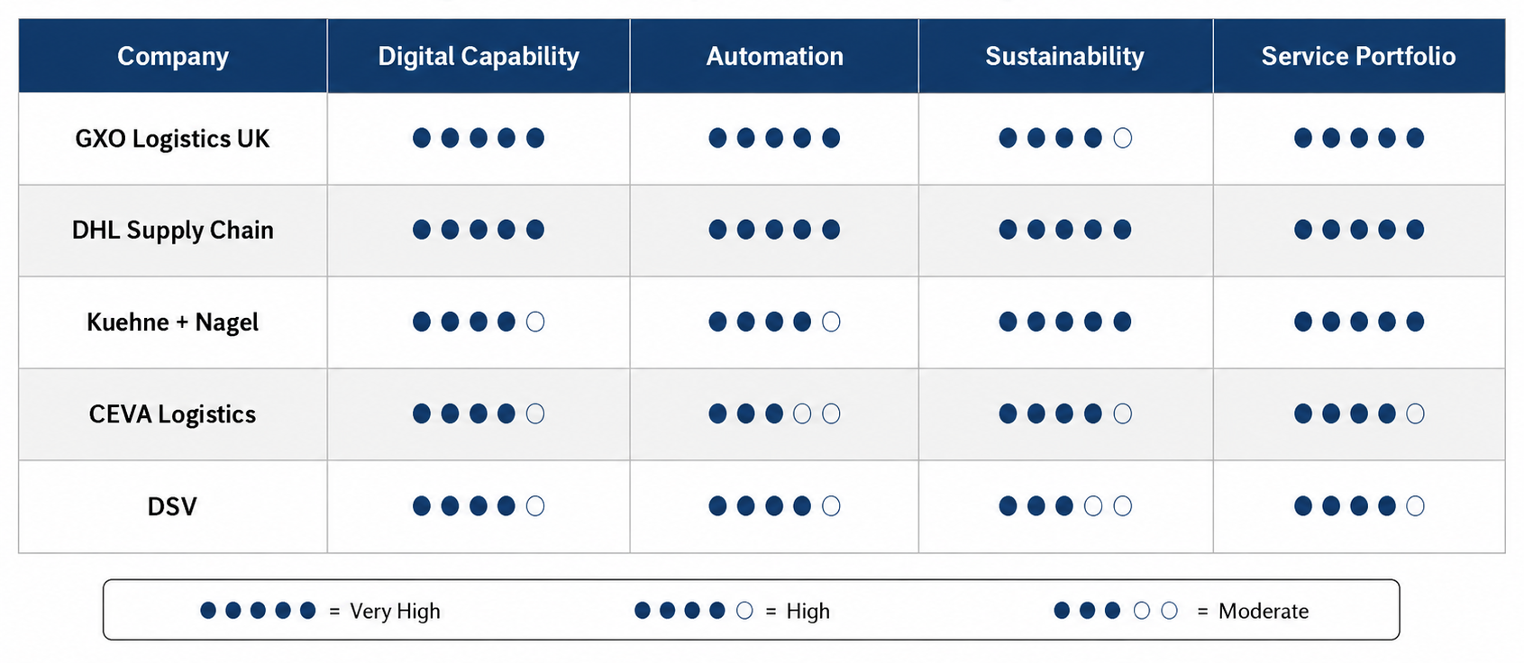
Figure 10: Competitor Positioning Matrix of Major UK Contract Logistics Providers
(Source: Self-created)
Operational excellence, digital transformation, customer integration, innovation capability, and organizational flexibility are competitive capabilities. On the other hand, the current literature does not pay much attention to the relationship between the discussed capabilities in terms of one contract logistics organization in the UK. This is why this study can be used as a theoretical framework of current research.

2.5 Competitor Analysis Literature
Logistics UK industry has been shown to be extremely competitive due to growing e-commerce and digitization trends as well as the changes in customer preferences. It has been found that digitalization, automation, and sustainability are the main factors that bring the competitive advantage in the UK logistics industry. According to the strategic management literature, benchmarking is the process of comparing the performance, operations and technology of an organization with industry leaders in order to identify the best practices and improve the situation. However, in terms of the logistics industry, it needs not only cost-efficiency but also warehouse automation, digitization, high-quality of customer services, supply chain visibility and sustainability performance.
In the first place, DHL Supply Chain can be regarded as one of the main competitors of GXO Logistics UK due to the implementation of the digital innovations in logistics. Using the digital innovations, DHL improves the productivity of warehouses and supply chain visibility by applying artificial intelligence, collaborative robotics, digital twin and Internet of things. Moreover, DHL Strategy 2030 focuses on automation, customer innovation and decarbonisation showing how technology investments can bring a competitive advantage. Also, Kuehne + Nagel applies digital freight platforms, cloud logistics systems and shipment tracking in real time. Recent research shows that the integration of digital technology and environmental sustainability can improve customer satisfaction and resilience in the case of contract logistics.
It is expected that acquisition of Wincanton by GXO Logistics in 2025 will bring the improvement of capacity, customer base and technology in the UK logistics market. Despite the fact that the previous research provides a deep analysis of the issues of logistics innovation, it does not account for the competition between logistics firms and their reaction to market changes. Therefore, it would be interesting to compare GXO Logistics UK with such companies as DHL Supply Chain, Kuehne + Nagel, CEVA Logistics and Wincanton.

2.6 Conceptual Framework
The conceptual framework offers a structured piece of the interrelations of concepts which are analysed in the research. It combines the findings of the literature review and applied theoretical approaches and helps to evaluate the strategic adaptation and competitive advantages of GXO Logistics UK in the logistics industry in the UK. Since the main focus of the research is the analysis of the strategic adaptation of the firm, the framework includes the external environment factors and internal capabilities of the firm and provides an explanation of the competitive advantage and business growth. The first step of the framework is the analysis of trends in the UK logistics industry: digital transformation, automation, sustainability, labour shortage, growing demands for e-commerce and higher customer expectations. According to the Dynamic Capabilities Theory, those organizations that can properly sense changes in the environment, capitalize them and reconfigure their resources can compete effectively in the future (Anh et al., 2026).
They affect the formation of the strategic capabilities of the firm: warehouse automation, digital technology, supply chain visibility, innovation capability, skilled labour force and CRM. According to the Resource-Based View (RBV) approach, the presence of those capabilities which cannot be copied by other organizations can provide the competitive advantage to the organization (Mailani et al., 2024). Nevertheless, besides possessing proper organizational capabilities, an organization needs to develop and adapt them to the changing market environment. These strategic decisions can help to improve the market position of the firm facing competitive pressures of DHL Supply Chain, Kuehne + Nagel, CEVA Logistics and DSV. Thus, it can be concluded that the competitive advantage is achieved not due to the possession of certain organizational capabilities but to the interaction of external industry trends, dynamic capabilities, strategic capabilities and competitive strategies.
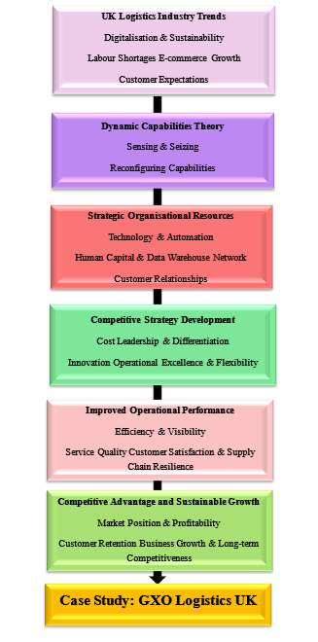
Figure 11: Conceptual Framework
(Source: Self-created)

2.7 Literature Gap
There is an abundance of literature that provides enough data about different aspects of the logistics industry, including digitalization, automation, sustainability and resilience of the supply chain (Ferreira & Reis 2023). Moreover, a lot of literature focuses on the competitive strategies of international logistics companies, and some consider the impact of innovations like artificial intelligence, robotics and IoT. However, there is a lack of literature that considers the integration of all the above-mentioned elements and adaptation of a particular logistics company to the market changes, its digital competence, and competitive advantage in the UK logistics market. On the contrary, there is almost no company-related research done concerning GXO Logistics UK, taking into account recent market changes such as the development of e-commerce, labour shortage, automation and acquisition of Wincanton in 2025.

2.8 Chapter Summary
The current chapter contains a literature review of the UK logistics industry and a theoretical background for analysis of the competitive position of GXO Logistics UK. It was found out that digital transformation, automation, sustainability, labour shortage, and the change in the expectations of the customers influenced the UK logistics market in 2020. Furthermore, the necessity of continuous innovation and adaptation was identified. The Dynamic Capabilities Theory, Resource-Based View, Porter's Generic Strategies and Porter's Five Forces were analyzed critically as supplementary theories that can help in understanding organisational competencies, competitive advantage and market situation. In addition, it was discovered that there is a gap in the existing literature because of the absence of research on GXO Logistics UK's competitive and innovative competencies.

Chapter 3: RESEARCH METHOD, ETHICAL IMPLICATIONS

3.1 Introduction
This chapter includes the discussion of the research methodology adopted to investigate the impact of digital transformation on the competitive strategy in GXO Logistics UK. This justifies the research design, secondary data sources and thematic analysis methods.

3.2 Research Design and Research Strategy
A qualitative single case study research design was adopted for critically examining how digital transformation influences the competitive strategy for GXO Logistics UK. Qualitative research is considered suitable because the research targets on the examination of the strategies, capabilities and competitive reaction of the organization (Tenny et al., 2022). A single case study does not support statistical generalization, but it can provide contextual and analytical insights into the phenomena going through investigation (Zhao et al., 2020).

3.3 Secondary Data Collection
This research used secondary data and it was collected from reliable academic and organizational sources. These sources consisted of peer-reviewed journals, annual reports of GXO Logistics, sustainability reports of GXO Logistics, GXO investor presentation, Logistics UK report, Office for National Statistics publications, Department for Transport report, Competition and Markets Authority publications, Reuters and Statista. Various sources of evidence allowed the data triangulation along with credibility of the research. Company reports are often a part of positive reporting bias, which makes it necessary to compare them with the independent academic literature and governmental sources to ensure the credibility of the study.
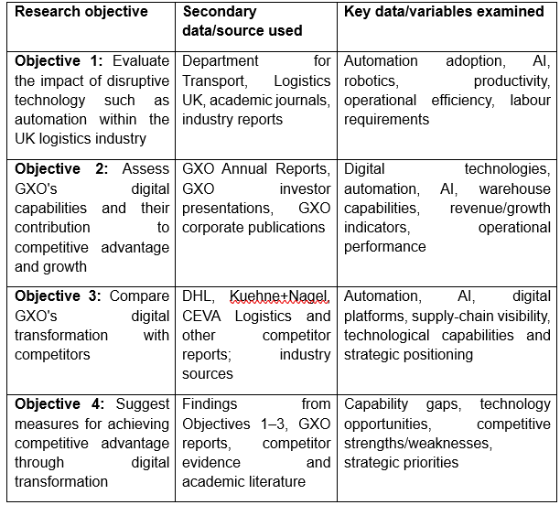
Table 1: Mapping of Secondary Data Sources to Research Objectives
(Source: Self-created)

3.4 Data Analysis Method
The data that has been gathered was evaluated with the assistance of qualitative thematic analysis which deals with the systematic review of the selected documents, coding and grouping of the recurring concepts into themes such as digital capabilities, competitive positioning, innovation and adaptation (Monge & Soriano, 2023). The themes were subsequently interpreted with the help of concepts utilised during the literature review such as the Dynamic Capabilities Theory; the Resource-Based View, Porter's Generic Strategies and Porter's Five Forces. Thematic analysis is a suitable approach as it enables synthesis of the evidence collected from various documentary sources along with detection of the patterns and contradictions (Ahmed et al., 2025). However, thematic interpretation depends on the researcher's interpretation. In order to promote the high level of analytical rigor, the coding process was linked with the research objectives, and the findings were discussed by comparing with multiple independent sources.

3.5 Ethical Considerations
There is a lack of ethical risk in the research because it uses only the secondary data that are publicly available and do not require human participation. Nevertheless, the ethical research should provide accurate evidence, and maintain referencing style while avoid plagiarism (Enago Academy, 2023).

3.6 Research Limitations
The study had main limitations due to its dependence upon the secondary data which restricted its access to confidential organizational data and employees' perspectives. Company reports often deliver reporting bias despite the data triangulation of the independent sources. Moreover, single case study design showcases limited generalizability of the findings to other logistics organizations. Nevertheless, this limitation remained appropriate as the main aim of the study is to evaluate the strategic reaction of GXO Logistics to digital transformation.

Chapter 4: CASE STUDY & ANALYSIS

4.1 Introduction
The aim of the present chapter is to examine the influence of the disruptive technologies on the UK logistics industry from the viewpoint of automation, robotics, artificial intelligence (AI), and data analytics regarding productivity, services, and competitiveness in the warehousing industry. The analysis is conducted using the secondary sources and focuses on the impact of the disruptive technologies concerning the GXO Logistics UK company. In 2025, the firm had 1,043 warehouses worldwide, 154,000 employees and managed 221 million square feet of warehouse space (Reuters, 2026).

4.2 Documented Operational Effects of Disruptive Technologies in UK Logistics

4.2.1 Automation and Robotics
Automation and robotics are inevitable means of solving problems related to productivity and labor force. According to Automate UK, sales of assembly-line robots to food, drink, logistics, and consumer goods companies increased by 31% in the first nine months of 2024, while the statistics do not include the sales of autonomous mobile robots (Butler, 2025). The GXO Logistics UK company uses the aforementioned technologies; besides, the company emphasizes that the employees working with robots are four to six times more productive, while the robotic automation allows sending five times more shipments (Demaitre, 2022). The figures should be considered as the self-referred ones and critically evaluated. Moreover, automation gave birth to job displacement while increasing technological independence.

4.2.2 Artificial Intelligence and Predictive Analytics
Artificial intelligence with predictive analytics has shaped the industry beyond automation and robotics and gives an opportunity to make decisions based on operational data. In 2026, 35% of UK firms employing at least 10 people applied at least one AI technology, while the average number of the AI technologies used per adopting firm was 1.6 (Stan, 2026). The research in 17 cases of adoption of the AI technologies has demonstrated that the cost, lead time, service and quality could be improved, while the barriers included data quality, skills, investment, and ROI uncertainty (Riad et al., 2024). The GXO Logistics UK company applies predictive analytics, machine learning, data science and warehouse management platform (GXO, 2026).

4.2.3 Documented Benefits and Costs of Automation
GXO implements autonomous mobile robots, collaborative robots, automated sortation and goods-to-person systems to achieve operational benefits (GXO Logistics, 2026). Nonetheless, automation involves substantial costs of capital expenditures, system integration and adaptation to new technologies for employees. In 2025, GXO spent $324 million on capital expenditures; however, it needs to be noted that the above figure is total expenditure and cannot be considered as technological investments only (GXO Logistics, 2026). Thus, automation cannot be recognized as a source of competitive advantage. It depends on the relationship between operational benefits and costs of automation as well as generation of value for customers.
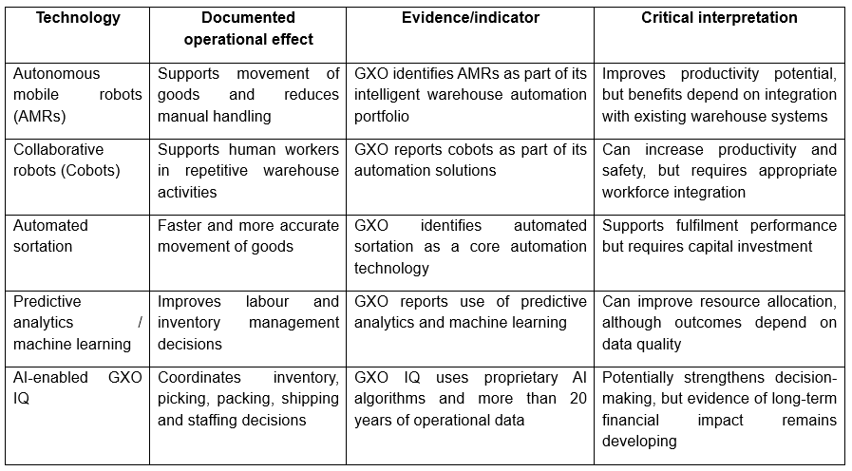
Table 2: Documented Operational Effects, Benefits and Costs of Automation
(Source: Self-created)

4.2.4 Critical Evaluation
Technology implies certain investments, data reliability, appropriate personnel and system integration. The overuse of technology results in the over-automation issue. The proper strategy in the use of technology is its combination with other sources of competitive advantage of the company.

4.3 GXO Logistics UK's Digital Investments and Capabilities

4.3.1 GXO's Digital Technology Investments
As per the 10-K form of 2025 of GXO, the company has 1,043 facilities around the world, which occupy 221 million square feet, and the technology portfolio of GXO includes autonomous robots, cobots, automated guided vehicles, goods-to-person technology, and sortation automation (S&P Global, 2026). 30 percent of income of GXO is generated by automated facilities. In 2025, new pilot projects for the use of humanoid robots were introduced by GXO (Walter, 2025). In contrast, as there is a requirement for investment, Implementation, and skills, automation calls for managerial attention and barely offers a competitive advantage.

4.3.2 AI, Data and Digital Supply-Chain Capabilities
Besides automated capability, the company also has digital capability such as AI and analytics. In 2025, the company implemented GXO IQ, which is an AI-first cloud-native platform with 20 years of experience and is designed to enhance the warehouse operations (GXO, 2025). This tool uses predictive analytics and machine learning technologies. Nevertheless, according to the research, the digital supply chain platform does not guarantee automatic generation of competitive advantage; the implementation of such a platform should be related to innovations and value creation (Alabdali & Salam, 2022).

4.3.3 Application of Dynamic Capabilities Theory
Under the Dynamic Capabilities Theory, technology investments of GXO represent competitive adaptation. Particularly, under the Dynamic Capabilities Theory, it is implied that there are concepts of sensing, seizing, and reconfiguration capabilities in the ever-changing competitive environment. Sensing capability of GXO is manifested by investments in automation, AI, and supply chain visibility. The development of GXO IQ platform and partnership with technology providers represent seizing, since digital assets are utilized for operations, but are not just purchased (GXO, 2025). Reconfiguration capability of GXO is represented by the development of a cloud-based platform, which enables innovations transfer among facilities and business verticals (Sun et al., 2025). Overall, in accordance with the recent literature on the adoption of AI in third-party logistics, dynamic capabilities help to integrate, learn, and reconfigure competencies when it comes to the adoption of AI (Vineet Chouhan et al., 2026). At the same time, the capability of GXO is not associated with using robots and AI, but rather integration of all the above tools. That is what makes the replication of the capability of GXO difficult for competitors

4.3.4 Application of Resource-Based View
Furthermore, the Resource-Based View (RBV) is used as another theoretical framework in order to explain the digital competitive capability of GXO (Ahn et al., 2022). The resources of GXO include logistics network, long-lasting relationships with customers, proprietary warehouse systems, operational knowledge, and experience of analysis and automation. Therefore, by 2025, GXO has 1,043 facilities with 154,000 employees in different countries across the globe, and that gives the firm the scale of innovation and implementation of digital solutions (S&P Global, 2026). Moreover, the intangible resource of the GXO IQ platform, which was developed based on the experience of GXO over 20+ years, is the intangible resource, which is difficult to replicate for the competitors (Demaitre, 2025). Nevertheless, some technologies, including AI and automation, could lose their rarity as other firms adopt them. That is why their combination is more powerful than technologies themselves.
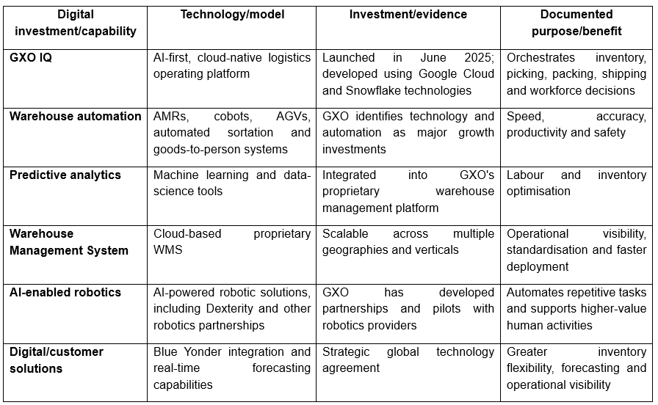
Table 3: GXO Logistics UK's Major Digital Technology Investments and Capabilities
(Source: Self-created)

4.4 Comparative Analysis of GXO Logistics UK and Industry Competitors

4.4.1 GXO vs DHL Supply Chain
By the beginning of 2025, GXO accomplished its UK footprint and today it generates £6.30 billion revenues in the country in comparison with £5.25 billion in 2024. In addition, GXO stated that the 50% of revenues for 2025 are already automated (Lee, 2025). The size of operations of DHL will be used as a benchmark for GXO since it generates €17.78 billion revenues from the supply chain, EBIT equals €1.16 billion, over 90% of warehouses are automated or digitized, and over 7,500 robots are used (GXO, 2025).

4.4.2 GXO vs Kuehne+Nagel and CEVA Logistics
Another example of a competitive model can be found at Kuehne+Nagel. The Contract Logistics business of Kuehne+Nagel generated CHF4.81 billion net turnover, over 600 locations, and over 70 automated locations in 2025 (Rani et al., 2026). Furthermore, the company claimed its AI-driven ecosystem for work process optimization (Rani et al., 2026). CEVA Logistics generated $18.3 billion gross revenue, 1,100 warehouses in 2025, and Manhattan cloud WMS and OMS are used for further automation optimization (Cevalogistics, 2019). Thus, GXO will be competing with other companies which have digital ambitions but realize them in a different way. For instance, the competitive advantage of GXO is in automation which provides a competitive advantage to its customers rather than being a competitive advantage in itself (Hamdouna & Khmelyarchuk, 2025).

4.4.3 Competitor Positioning
Finally, the analysis demonstrates that GXO stays competitive in terms of warehouse automation; however, the gap between the company and its competitors narrows. While 50% of revenues of GXO are generated by automation, DHL announced over 90% automation or digitization of its warehouses (Demaitre, 2022). Over 70 highly automated contract-logistics locations integrated with AI exist at Kuehne+Nagel, while CEVA uses Manhattan for WMS upgrading.
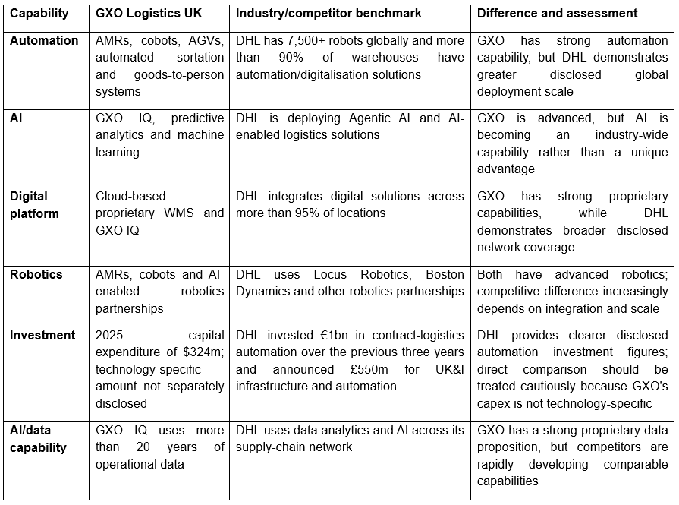
Table 4: Comparison of GXO's Digital Capabilities with Major Logistics Competitors
(Source: Self-created)

4.4.4 Application of Porter's Five Forces
Porter's Five Forces show very intensive competition. The competition level is high as there are many competitors including DHL, CEVA, Kuehne+Nagel, DSV etc., and the expansion and technology investments increase competition. The power of buyers is high because large-scale buyers may take into account providers according to such aspects as cost, reliability, visibility, and technology, therefore, differentiation is required. The power of suppliers is moderate because of automation that results in the necessity of less labor force, but GXO depends on technology providers, competent workforce, and growing salaries. The threat of new entrants is low because of globalization, investment in capital resources, relationships with customers, and technologies that allow economies of scale, but cloud technologies reduce some of these factors. The threat of substitutes is moderate because the customers may opt for internal logistics services or other 3PLs. Thus, innovations, competence of the workforce, and customers' engagement are more important than technologies for obtaining competitive advantage (Nastase et al., 2025).

4.5 GXO's Competitive Strategy and Competitive Advantage

4.5.1 Application of Porter's Generic Strategies
As per Porter's generic strategies this differential could provide competitive advantage when any certain characters allow creating value for the customers. GXO retained differentiation with the help of technologies such as cloud-based warehouse management, predictive analytics, machine learning for supporting faster, accurate and transparent labour efficient fulfilment (Rainer et al., 2025). In contrast, Porter’s framework could barely be implemented strictly as the industry is constantly changing whereas more companies are adopting automation with AI. For instance, DHL Supply Chain generated €17.778 billion in revenue in 2025, supported by digitalisation with automation and standardisation (DHL Group, 2025). Hence, GXO’s advantage relies on the utilization of these technologies, but it coordinates with data, procedures along with consumer specific solutions.

4.5.2 Digital Transformation → Competitive Advantage
The digital transformation of GXO supports competitive advantage while optimising operational performance. As per GXO’s 2025 filing, technology helps with lowering the cost, while optimising efficiency and accuracy and supporting the environmental performance. In contrast these results were impacted by acquisition and new contracts. Hence competitive advantage comes from the utilisation of technology in order to build stronger organisational capabilities. As suggested by Shehadeh et al. (2023) digital technology could optimize the supply chain capabilities, agility along with flexibility.
Therefore, the competitive advantage of GXO comes from productivity, visibility with responsiveness and differentiation. GXO therefore needs to keep on developing and adapt to its capabilities.

4.6 Key Findings and Strategic Implications
Overall, the findings hint towards the digital transformation which turned out to be an important part of GXO Logistics UK’s competitive strategy, although the benefits of technology are not automatic. Regarding Objective 1, automation, AI, predictive analytics and robotics can improve efficiency, speed, accuracy and visibility. However, the associated costs, integration challenges and labour requirements mean that technology does not necessarily lead to better performance in every situation (Nagy et al., 2023).
Regarding Objective 2, GXO demonstrates strong digital capabilities. Its 2025 filing identifies intelligent warehouse automation, predictive analytics and a cloud-based warehouse management platform as important capabilities. Gross property related to technology with automated equipment amounts to $582 million in December 2025 and it increased from $531 million in 2024. In contrast, this figure consists of beyond digital investment. UK revenue also enhanced from $5.248 billion to $6.296 billion and the reason is Wincanton.
Objective 3 showcases that there is immense competition in the industry. DHL Supply chain generated almost €17.778 billion in revenue in 2025while it reported the progress in digitisation with automation (). Furthermore, Kuehne+Nagel Contract Logistics has attained CHF4.805 billion in net turnover (Statista, 2025). This showcases that technology has turned to be an immediate requirement for gaining competitive advantage in the market.
Objective 4 showcases that GXO demands the amalgamation of AI, automation, and data with employee skills in resolving consumer issues. Hence, keeping up the competitive advantage calls for constant development of the organizational capabilities instead of new and updated ones.
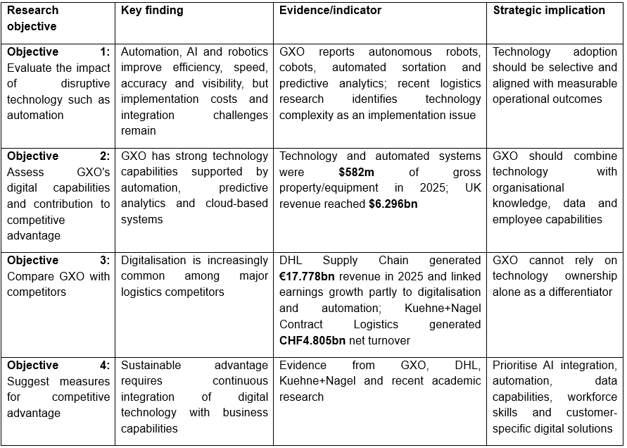
Table 5: Summary of Findings Against Research Objectives
(Source: Self-created)
Altogether, the academic literature helps in supporting the view where digital technology results in competitive advantage while evaluating the supply chain capabilities in place of technology ownership and beyond.

Chapter 5: CONCLUSION & RECOMMENDATIONS

5.1 Introduction
This chapter represents the end of the research of the digital transformation and competitive strategy of GXO Logistics UK. Moreover, it provides the summary of all the findings and analyzes their compliance with the research objectives and offers some recommendations about the development of digital competencies of GXO, its differentiation and strategic position in the future.

5.2 Overall Conclusion
It is shown that the digital transformation becomes crucial for the competitive strategy of GXO Logistics UK; however, technology is not the guarantor of competitive advantage. The organization has gained competencies in automation, robotics, predictive analytics, artificial intelligence and digital warehouse management and has integrated technology into the contract logistics model. Besides, the discussed strategy can be described as consistent with the dynamic capabilities theory according to which the competitiveness of an organization depends on its ability to react to the changes in the environment thanks to technological possibilities.
As for the financial performance, there is considerable business growth. GXO has reported the global revenue of $13.178 billion in 2025 compared to $11.709 billion in 2024; the revenue in the UK has increased from $5.248 billion to $6.296 billion. Nevertheless, the company notes that the growth of $655 million was the result of the acquisition of Wincanton, meaning that the digital transformation cannot be seen as the only factor influencing the increase of revenue (GXO, 2025). Therefore, the success of GXO in the future will depend on the proper integration of technology with other resources.

5.3 Conclusions Against Research Objectives
- Objective 1: Evaluate the documented operational effects of disruptive technologies
Findings revealed that automation, robotics, artificial intelligence, and predictive analytics possess operationally proven efficiency, speed, precision, and reduced manual labour. However, the adoption of these technologies demands significant capital, efficient system integration and employee adaptation. Thus, findings support the statement that disruptive technologies may help to improve performance operationally but fail to show the causal link between technologies and financial performance of GXO.
- Objective 2: Assess GXO’s digital capabilities
The findings suggested that GXO has high digital capabilities as it makes use of automation, predictive analytics, machine learning and cloud-based warehouse management systems. As per Terex Corporation (2026) technology is one of the essential factors that helps in attracting and retaining consumers with the value of technology and automated-systems property and equipment estimated at $582 million by the year ending of 2025. Nevertheless, the technology investment could not be called sufficient for developing the competitive advantage. The strategic value is determined with the integration of organizational resources, capabilities of the employees and solutions for the customers.
- Objective 3: Compare GXO with competitors
The comparison has depicted that GXO carries out its operation within a very technology-intensive competitive environment. The competitors such as DHL reported €17.778 billion in its supply chain revenue in the year 2025, where the associated productivity increased with digitalization and automation (DHL Group, 2025). Moreover, Kuehne+Nagel's Contract Logistics division earned about CHF4.805 billion in its net turnover in 2025 by running 70 highlighted automated facilities (Statista, 2025). Therefore, the ability of GXO to differentiate itself from others becomes increasingly dependent upon the integration of technologies for providing solutions to its customers.
- Objective 4: Suggest measures for competitive advantage
The findings depicted that GXO logistics should not have their continuous focus on acquiring the technologies but should also try to develop organizational capabilities. To be more specific, GXO must enhance their AI implementation, employee competencies, data management along with the integration of customer-specific solutions.

5.4 Recommendations for GXO Logistics UK
- Integrate AI with Operational Data and Decision-Making
It is important for GXO to move further from the mere use of separate AI instruments and develop a unified system of AI and data management that will integrate warehouse management, inventory management, labor planning, forecasting, and customer data. The recommendation is provided because of the launch by the company of GXO IQ that is a cloud-based platform based on the technology of Google Cloud and Snowflake and designed to manage warehousing, transportation, and workforce (GXO, 2025). The implementation should be accompanied by data governance, human supervision, and KPIs that could include forecasting accuracy, inventory productivity, and order-processing time.
- Prioritise Automation Through Evidence-Based Investment
GXO should invest in automation but do it only on the basis of operational needs and benefits rather than on the basis of technology adoption alone. The technologies that could have potential to increase speed, accuracy, and productivity were autonomous robots, cobots, automated sortation, automated guided vehicles, and goods-to-person technology (Balaska et al., 2022). In 2025, the property and equipment related to technology and automation of GXO amounted to $582 million, while it was $531 million in 2024 (Terex Corporation, 2026). Therefore, GXO should pay more attention to the automation that can lead to increases in productivity or accuracy.
- Convert Digital Capability into Customer-Focused Differentiation
GXO should use digital technologies to create customer-specific value but not to see technology capability as an advantage itself. GXO uses a cloud-based warehouse management platform that allows for implementing innovations in different geographic locations and different customer segments (Rosário & Raimundo, 2024). Thus, the capability should be used by providing customer dashboards, real-time visibility, predictive alerts, and data-driven fulfillment services. The recommendation is justified because of the competitors of GXO developing the same digital capabilities. Thus, GXO should differentiate itself through the integration of technology in customer solutions.
- Develop a Technology-Enabled Workforce
Besides the investments of GXO in automation and AI, the company should focus on continuous development of the digital competencies of its employees. This training would consist of data analysis, using the warehouse management systems, robotics, AI-powered decision-making tools as well as technology troubleshooting. Thus, in this view the workforce development must be seen as one of the significant parts of technology investment but not as an independent HR activity. With the help of a workforce that has higher levels of competency, it would help GXO to create dynamic capabilities.
- Build Integrated Capabilities That Competitors Cannot Easily Replicate
Lastly, GXO should focus on the development of its integrated capabilities combining technologies, proprietary operational data, employee expertise, customer relationships, and organizational knowledge. GXO should consequently assess the digital performance in terms of productivity, customer retention, implementation, service quality, and customer-specific value but not technology expenditure alone.

5.5 Implementation Priorities
The short-term priorities for GXO logistics would be the implementation of AI, data management along with mentoring the employee. The growth of automation and development of customer-oriented technologies should be the key areas of activity in the medium term. This would allow GXO to create distinctive competitive advantages due to proper use of technology and innovation in the long term.

5.6 Future Research
The future research could have the focus upon the comparisons of GXO logistics with the DHL, Kuehne+Nagel, and CEVA by conducting qualitative interviews of logistics managers and employees of these companies. It is possible to conduct quantitative research to study the connection between the level of investment in technology, efficiency, customer retention and financial performance. Additionally, longitudinal studies may determine whether GXO's digital capabilities help maintain a sustainable competitive advantage.
In general, the competitiveness of GXO Logistics UK in the future will depend not on the level of investment in technology compared to competitors, but on the proper combination of technology, organizational capabilities, and skills of employees.

References
Agrawal, T. K., Kalaiarasan, R., Olhager, J., & Wiktorsson, M. (2024). Supply chain visibility: A Delphi study on managerial perspectives and priorities. International Journal of Production Research, 62(8), 2927-2942. https://doi.org/10.1080/00207543.2022.2098873
Ahmed, S. K., Mohammed, R. A., Nashwan, A. J., Ibrahim, R. H., Abdalla, A. Q., Ameen, B. M. M., & Khidhir, R. M. (2025). Using thematic analysis in qualitative research. Journal of Medicine, Surgery, and Public Health, 6(6), 100198. ScienceDirect. https://doi.org/https://doi.org/10.1016/j.glmedi.2025.100198.
Ahn, S., Kim, K.-S., & Lee, K.-H. (2022). Technological Capabilities, entrepreneurship and innovation of technology-based start-ups: The resource-based view. Journal of Open Innovation: Technology, Market, and Complexity, 8(3), 156. https://doi.org/10.3390/joitmc8030156.
Al Humdan, E. (2026). Governing agility: introducing supply chain meta-agility as a second-order dynamic capability in supply chains. Review of Managerial Science, 1-25. https://link.springer.com/article/10.1007/s11846-026-01014-z
Al Zadajali, A., & Ullah, A. (2024). The effectiveness of logistics services on firms’ performances–A literature review. American Journal of Economics and Business Innovation, 3(1), 125-132. https://www.researchgate.net/profile/Asad-Ullah-17/publication/379738470_The_Effectiveness_of_Logistics_Services_on_Firms'_Performances_-_A_Literature_Review/links/669de47e8dca9f441b8eef3c/The-Effectiveness-of-Logistics-Services-on-Firms-Performances-A-Literature-Review.pdf
Alabdali, M. A., & Salam, M. A. (2022). The impact of digital transformation on supply chain procurement for creating competitive advantage: An empirical study. Sustainability, 14(19), 12269. https://doi.org/10.3390/su141912269.
Alkaraan, F., Floyd, D., Rahman, M., & Nuery, N. (2023). A new era of strategic investment decision-making practices in UK companies: Towards sustainable supply chains and circular economy. Theoretical Economics Letters, 13(3), 666-682. https://d1wqtxts1xzle7.cloudfront.net/122749127/PaperDownload-libre.pdf?1746996415=&response-content-disposition=inline%3B+filename%3DA_New_Era_of_Strategic_Investment_Decisi.pdf&Expires=1783678115&Signature=Qy~l9BbzfXKpIb3~3WovTDSRACrVsERkUnk6kj3l5yFn0JhzbIF5x2ByClmrYVKsF6szgWVoGCAozV1k8PNzPIOqpKnqBgmamGd45LlIOhRGAz42uM6u6CnU8nbIJr4DGfjFh~R39Qm6XXy5nhWmS7zgKpBQil-24NfnpLdKqVzS-vTElKlosASOXXTXjIyi6dTw691cD6yTSmp4aATheyCermbzipIo-NDNa2vAtMZtorF9IalOwI4~WFi7F402YbcqZbYVbM8YdB8NSMMtrpLafDIZLvGFh9TgJAI8gxbJ5u~XzQyzAnHYWhSoG3UFPvGn2wksGCXlSDjWvlJmg__&Key-Pair-Id=APKAJLOHF5GGSLRBV4ZA
Anh, N. T. P., Khoi, B. H., Thu, N. Q., & Ghi, T. N. (2026). The role of the level of artificial intelligence adoption on business model innovation, sustainable competitive advantage, and firm performance: Integrating the TOE framework and Dynamic Capabilities theory. Green Technologies and Sustainability, 100384. https://doi.org/10.1016/j.grets.2026.100384
Balaska, V., Tsiakas, K., Giakoumis, D., Kostavelis, I., Folinas, D., Gasteratos, A., & Tzovaras, D. (2022). A viewpoint on the challenges and solutions for driverless last-mile delivery. Machines, 10(11), 1059. https://doi.org/10.3390/machines10111059.
Barykin, Sergey & Kapustina, Irina & Sergeev, Sergey & Yadykin, Vladimir. (2020). Algorithmic Foundations of Economic and Mathematical Modeling of Network Logistics Processes. Journal of Open Innovation: Technology, Market, and Complexity. 6. 189. 10.3390/joitmc6040189. https://doi.org/10.3390/joitmc6040189
Brewis, C., Dibb, S., & Meadows, M. (2023). Leveraging big data for strategic marketing: A dynamic capabilities model for incumbent firms. Technological Forecasting and Social Change, 190, 122402. https://doi.org/10.1016/j.techfore.2023.122402
Butler, S. (2025). Robot packers and AI cameras: UK retail embraces automation to cut staff costs. In The Guardian. https://www.theguardian.com/business/2025/jan/21/robot-packers-and-ai-cameras-uk-retail-embraces-automation-to-cut-staff-costs.
Cevalogistics. (2019). Facts & figures - CEVA logistics financials. In Cevalogistics.com. https://www.cevalogistics.com/en/who-we-are/about-ceva-logistics/facts-and-figure
Clarke, S., Gasiorek, M., & Hernandez, A. S. (2023). The challenges facing UK firms: trade and supply chains. UK Trade Policy Observatory Briefing Paper, 73. https://blogs.sussex.ac.uk/uktpo/files/2023/03/73-final.pdf
Competition and Markets Authority. (2024). Full text decision. https://assets.publishing.service.gov.uk/media/675177aa44885d072cecbcda/1._Full_text_decision.pdf
Demaitre, E. (2022, March 4). Supply chain 24/7. Supply Chain 24/7. https://www.supplychain247.com/article/gxo_logistics_grows_with_ecommerce_returns_automation.
Demaitre, E. (2025). Gxo IQ designed to intelligently manage logistics operations - automated warehouse. In Automated Warehouse. https://www.automatedwarehouseonline.com/gxo-iq-intelligently-manages-logistics-operations/.
Department for Transport. (2024). Future skills assessment in the transport sector. National Skills Academy for Rail. https://assets.publishing.service.gov.uk/media/671b652f956d9b52e8c6d25c/dft-future-skills-assessment.pdf
DHL Group. (2025). Supply chain division. In Dhl.com. https://reporting-hub.group.dhl.com/2025-fy/en/combined-management-report/report-on-economic-position/supply-chain-division-1/.
Enago Academy. (2023). How to avoid plagiarism in research papers (Part1). In Enago Academy. https://www.enago.com/academy/how-to-avoid-plagiarism-in-research-papers/.
Ferreira, B., & Reis, J. (2023). A Systematic Literature Review on the Application of Automation in Logistics. Logistics, 7(4), 80. https://doi.org/10.3390/logistics7040080
Grand View Research. (2024, June 28). UK logistics market size & outlook, 2026–2033. https://www.grandviewresearch.com/horizon/outlook/logistics-market/uk
GXO Logistics, Inc. (2025). Annual report pursuant to Section 13 or 15(d) of the Securities Exchange Act of 1934 (Form 10-K) for the fiscal year ended December 31, 2024. U.S. Securities and Exchange Commission. https://www.sec.gov/Archives/edgar/data/1852244/000185224425000007/gxo-20241231.htm
GXO. (2022). GXO deploys most technology in its history - GXO | supply chain management | 3PL contract logistics. In gxo.com. https://gxo.com/news_article/gxo-deploys-most-technology-in-its-history/.
GXO. (2025). GXO launches gxo IQ, an AI-first platform built for logistics - GXO | supply chain management | 3PL contract logistics. In GXO | Supply Chain Management | 3PL Contract Logistics. https://gxo.com/news_article/gxo-launches-gxo-iq-a-first-of-its-kind-ai-first-platform-to-power-global-supply-chain-operations/.
GXO. (2026). Logistics - GXO | supply chain management | 3PL contract logistics. In gxo.com. https://gxo.com/.
Hamdouna, M., & Khmelyarchuk, M. (2025). Technological innovations shaping sustainable competitiveness—A systematic review. Sustainability, 17(5), 1953–1953. https://doi.org/10.3390/su17051953.
Hayton, J. (2023). Organisational adoption of automation technologies Literature review. Institute for the Future of Work. https://static1.squarespace.com/static/61e471292531e621931e557d/t/64e4734708a23457e7160c9f/1692693321539/Organisational+Adoption+of+Technologies+Literature+Review.pdf
He, J., Fan, M., & Fan, Y. (2024). Digital transformation and supply chain efficiency improvement: An empirical study from a-share listed companies in China. PloS One, 19(4). https://doi.org/10.1371/journal.pone.0302133.
Hopkins, D., Medappa, K., Davidson, A. C., Gregson, N., & James, A. (2024). Views from the cab: the working lives of heavy goods vehicle drivers in the UK. https://ora.ox.ac.uk/objects/uuid:546d5789-9592-438a-8623-ab04e885aa83/files/smg74qn864
Huang, Y.-F., Phan, V.-D.-V., & Do, M.-H. (2023). The Impacts of Supply Chain Capabilities, Visibility, Resilience on Supply Chain Performance and Firm Performance. Administrative Sciences, 13(10), 225. https://doi.org/10.3390/admsci13100225
Ifty, M. E. S. (2025, July). The Use of Artificial Intelligence in Logistics. In Young Scientist, Conference/Jaunasis mokslininkas, konferencija (pp. 172-177). https://portalcris.vdu.lt/server/api/core/bitstreams/05c1a7c8-ca99-45ca-bd2d-dc9874840f66/content
IMARC Group. (2026, June 18). UK logistics market size, share, trends and forecast by model type, transportation mode, end use, and region, 2026–2034. https://www.imarcgroup.com/uk-logistics-market
Jacobs, Jonatan & Pretorius, M.W.. (2020). THE MAJOR CHALLENGES FACING ORGANISATIONS TO CREATE TECHNOLOGY-ENABLED VALUE IN THE FOURTH INDUSTRIAL REVOLUTION: A DYNAMIC CAPABILITIES PERSPECTIVE IN SOUTH AFRICA. South African Journal of Industrial Engineering. 10.7166/31-2-2345. https://doi.org/10.7166/31-2-2345
John, J. M., Shobayo, O., & Ogunleye, B. (2023). An exploration of clustering algorithms for customer segmentation in the UK retail market. Analytics, 2(4), 809-823. https://doi.org/10.3390/analytics2040042
Kotlyk, A., Lin, L., & Yantao, L. (2024). Innovations as a way to adapt to uncertainty conditions. https://repository.hneu.edu.ua/bitstream/123456789/34921/1/Kotlyk,%20Liu,%20Liu%20Innovations%20as%20a%20way%20to%20adapt%20to%20uncertainty%20conditions%20(1).pdf
Lee, A. (2025, August 12). GXO Q2 deep dive: New vertical expansion and automation drive momentum. StockStory. https://stockstory.org/us/stocks/nyse/gxo/news/earnings-call/gxo-q2-deep-dive-new-vertical-expansion-and-automation-drive-momentum.
Logistics UK. (2025, June 4). UK's £170 billion logistics sector is unsung hero of the economy, says Logistics UK. https://logistics.org.uk/media/press-releases/2025/june/uk-s-170-billion-logistics-sector-is-unsung-hero-o
Mailani, D., Hulu, M. Z. T., Simamora, M. R., & Kesuma, S. A. (2024). Resource-based view theory to achieve a sustainable competitive advantage of the firm: Systematic literature review. International Journal of Entrepreneurship and Sustainability Studies, 4(1), 1. https://www.proquest.com/openview/715f70158b1b2ea8c9e077e44585c6ba/1?pq-origsite=gscholar&cbl=7201586
Mao, Ninghui. (2023). Investigation of the Commercial Potential of Emulsified Asphalt Cold In-Place Recycling Based on SWOT Analysis. Open Journal of Business and Management. 11. 3135-3151. 10.4236/ojbm.2023.116172. https://doi.org/10.4236/ojbm.2023.116172
Masriadi, D., Ekaningrum, N. E., Hidayat, M. S., & Yuliaty, F. (2023). Exploring the future of work: Impact of automation and artificial intelligence on employment. Endless International Journal of Future Studies, 6(1), 125-136. https://pdfs.semanticscholar.org/4364/e95b6a3c4b4ed6c72b7083b9f08a7ebbf602.pdf
Minh, T. L., Ngo, V. M., Hong Nguyen, N. T., Nghiem Thai, M. N., & Truong, N. T. (2024). Logistics service quality, customer satisfaction and retention: Moderating effects of technological capability. Academic Journal of Interdisciplinary Studies, 13(5), 163. https://www.researchgate.net/profile/Triet-Le-Minh-2/publication/386083423_Logistics_Service_Quality_Customer_Satisfaction_and_Retention_Moderating_Effects_of_Technological_Capability/links/67429bd7868c966b932a37a0/Logistics-Service-Quality-Customer-Satisfaction-and-Retention-Moderating-Effects-of-Technological-Capability.pdf
Monge, E. C., & Soriano, D. R. (2023). The role of digitalization in business and management: A systematic literature review. Review of Managerial Science, 18(1), 449–491. https://doi.org/10.1007/s11846-023-00647-8.
Nagy, M., Lăzăroiu, G., & Valaskova, K. (2023). Machine Intelligence and autonomous robotic technologies in the corporate context of SMEs: Deep learning and virtual simulation algorithms, cyber-physical production networks, and industry 4.0-Based manufacturing systems. Applied Sciences, 13(3), 1681. https://doi.org/10.3390/app13031681.
Nanyangwe, Janet & Phiri, Jackson. (2021). The Influence of Marketing Strategies on Growth and Sustainability in the Original Equipment Manufacturing Industry. Open Journal of Business and Management. 09. 1446-1461. 10.4236/ojbm.2021.93077. https://doi.org/10.4236/ojbm.2021.93077
Nastase, C., Andreea Adomnitei, & Anisoara Apetri. (2025). Strategic human resource management in the digital era: Technology, transformation, and sustainable advantage. Merits, 5(4), 23–23. https://doi.org/10.3390/merits5040023.
Office for National Statistics. (2024, October 14). User guide to consumer trends. https://www.ons.gov.uk/economy/nationalaccounts/satelliteaccounts/methodologies/consumertrendsuk
Parcel Perform. (2025, March 25). How AI-powered e-commerce logistics solves WISMO and reduces costs. https://www.parcelperform.com/insights/how-ai-reduces-ecommerce-logistics-costs.
Rainer, R. K., Richey, R. G., & Chowdhury, S. (2025). How robotics is shaping Digital Logistics and supply chain management: An ongoing call for research. Journal of Business Logistics, 46(1). https://doi.org/10.1111/jbl.70005.
Rani, S., Karnati, R., Patel, V., Ranganathaswamy, M. K., Tomar, P., Kataria, A., & Pal, A. (2026). AI-driven optimization techniques for smart sustainable manufacturing in industry 5.0 ecosystem: A comprehensive review. Alexandria Engineering Journal, 137, 133–158. https://doi.org/10.1016/j.aej.2026.01.016.
Reuters. (2026, May 5). (GXO.n) | stock price & latest news | Reuters. Reuters.Com. https://www.reuters.com/markets/companies/GXO.N/.
Riad, M., Naimi, M., & Okar, C. (2024). Enhancing Supply Chain Resilience Through Artificial Intelligence: Developing a Comprehensive Conceptual Framework for AI Implementation and Supply Chain Optimization. Logistics, 8(4), 111. https://doi.org/10.3390/logistics8040111
Riad, M., Naimi, M., & Okar, C. (2024). Enhancing supply chain resilience through artificial intelligence: Developing a comprehensive conceptual framework for AI implementation and supply chain optimization. Logistics, 8(4), 111. https://doi.org/10.3390/logistics8040111.
Rishi, Mohit & Dwivedi, Prasoom & Ghosal, Avishek. (2022). Application of RBV Theory in Business Management - A Bibliometric Analysis. Acta Universitatis Bohemiae Meridionalis. 25. 138-161. 10.32725/acta.2022.015. https://doi.org/10.32725/acta.2022.015
Rosário, A. T., & Raimundo, R. (2024). Internet of things and distributed Computing Systems in business models. Future Internet, 16(10), 384. https://doi.org/10.3390/fi16100384.
S&P Global. (2026). Research update: GXO Logistics Inc. ‘BBB-’ rating | S&P global ratings. Spglobal.Com. https://www.spglobal.com/ratings/en/regulatory/article/-/view/type/HTML/id/3530461.
Shahadat, M. M. H., Chowdhury, A. H. M. Y., Nathan, R. J., & Fekete-Farkas, M. (2023). Digital Technologies for Firms’ Competitive Advantage and Improved Supply Chain Performance. Journal of Risk and Financial Management, 16(2), 94. https://doi.org/10.3390/jrfm16020094
Shehadeh, M., Almohtaseb, A., Aldehayyat, J., & Abu-AlSondos, I. A. (2023). Digital Transformation and competitive advantage in the service sector: A moderated-mediation model. Sustainability, 15(3), 2077. https://doi.org/10.3390/su15032077.
Shiferaw, R. M., & Amentie Kero, C. (2024). Dynamic capabilities view practices of business firms: a systematic literature review. Cogent Business & Management, 11(1). https://doi.org/10.1080/23311975.2024.2336309
Song, F., Xu, Y., Chen, H., & Zhang, K. (2024). Better to deliver tomorrow morning than late today? The time‐of‐day effect in customer perception of online sellers' logistics service quality. Transportation Journal, 63(4), 263-278. https://doi.org/10.1002/tjo3.12017
Stan, A. M. (2026, July 22). UK businesses have tripled their AI adoption. Most are still barely scratching the surface. The Next Web. TNW | Artificial-Intelligence. https://thenextweb.com/news/uk-ai-adoption-widening-not-deepening-ons-2026.
Statista. (2025). Kuehne + Nagel’s worldwide revenue 2025. Statista. https://www.statista.com/statistics/264352/kuehne-and-nagels-worldwide-revenue-since-2006/?srsltid=AfmBOooWgxYSgLRW9ID-uf2InQxJKuPoAi5MkmRgCZf18L4bm4lqf5T2.
Sun, B., Yu, J., Khattak, S. I., Tariq, S., & Zahid, M. (2025). Digital Innovation, business models transformations, and agricultural SMEs: A PRISMA-Based review of challenges and prospects. Systems, 13(8), 673. https://doi.org/10.3390/systems13080673.
Tenny, S., Brannan, J., & Brannan, G. (2022). Qualitative study. In National Library of Medicine. StatPearls Publishing. https://www.ncbi.nlm.nih.gov/books/NBK470395/.
Terex Corporation. (2026, February 11). Terex reports fourth quarter and full-year 2025 results. Cision PR Newswire. PRNewswire. https://www.prnewswire.com/news-releases/terex-reports-fourth-quarter-and-full-year-2025-results-302684311.html.
Tuominen, S., Reijonen, H., Nagy, G., Buratti, A., & Laukkanen, T. (2023). Customer-centric strategy driving innovativeness and business growth in international markets. International marketing review, 40(3), 479-496. https://doi.org/10.1108/IMR-09-2020-0215
Verma, N. (2026). Empowering Small Businesses Through AI-Driven Supply Chain Tools: Democratizing Cost Intelligence For Competitive Advantage. Journal of International Crisis and Risk Communication Research, 9(1), 262. https://www.proquest.com/openview/aa47e291705c2610412c0fe75331e41f/1?pq-origsite=gscholar&cbl=6480378
Vineet Chouhan, Pranav Saraswat, & Goswami, S. (2026). AI’s role in efficient logistics management: Shaping the future of supply chain in India. Transportation Research Interdisciplinary Perspectives, 39, 102149–102149. https://doi.org/10.1016/j.trip.2026.102149.
Walter, N. (2025). GXO follows big tech’s lead as it expands humanoid trials in warehouses. In Interesting Engineering. https://interestingengineering.com/innovation/gxo-bets-on-humanoid-robots.
Wolf, C. D. (2026, February 19). GXO closes out record-setting revenue year. Transport Topics. https://www.ttnews.com/articles/gxo-earnings-q4-2025.
Zhao, N., Hong, J., & Lau, K. H. (2023). Impact of supply chain digitalization on supply chain resilience and performance: A multi-mediation model. International journal of production economics, 259, 108817. https://doi.org/10.1016/j.ijpe.2023.108817.
Zhao, Y., von Delft, S., Morgan-Thomas, A., & Buck, T. (2020). The evolution of platform business models: Exploring competitive battles in the world of platforms. Long Range Planning, 53(4), 101892 https://www.sciencedirect.com/science/article/pii/S0024630118306368.

Appendix

Appendix A – Study Summary Table
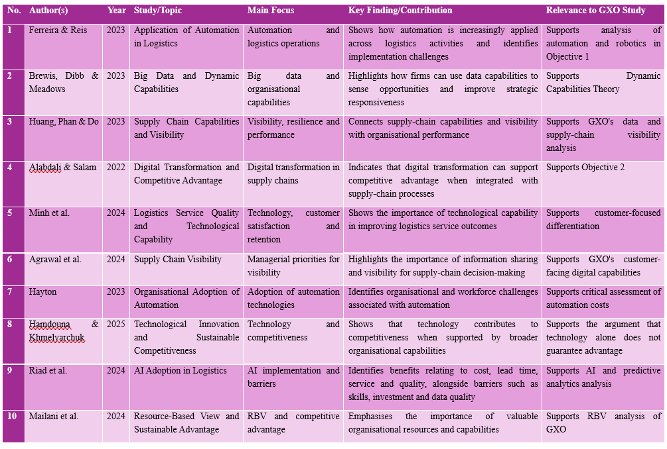

Appendix B – Secondary Data Extraction Matrix
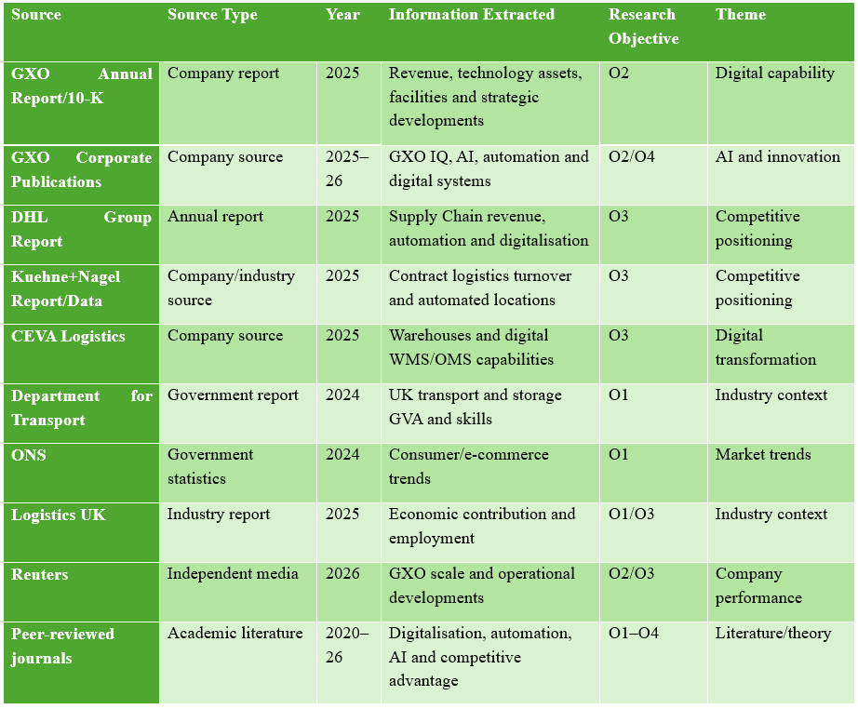

Appendix C – Search Strategy
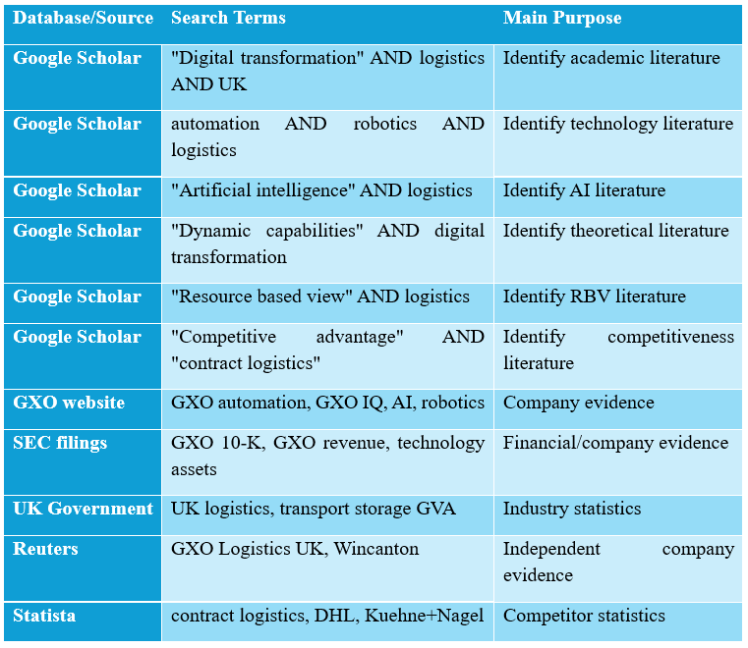

Appendix D – Thematic Coding Framework
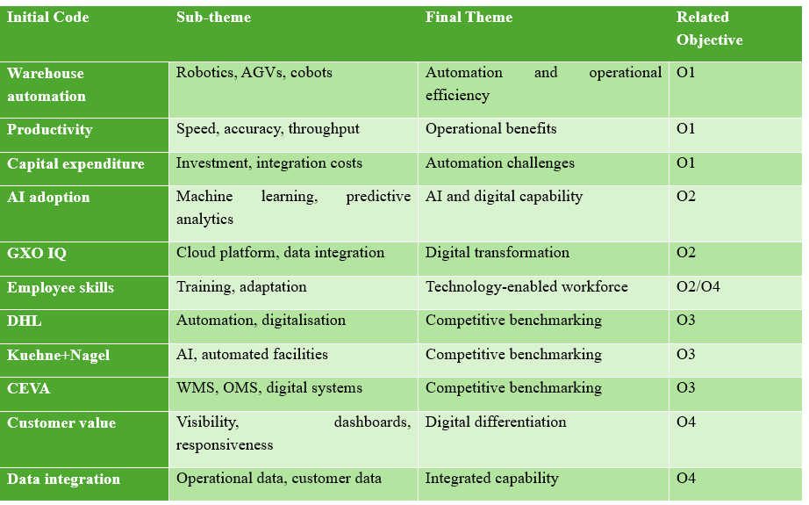

Appendix E – Competitor Benchmarking Data
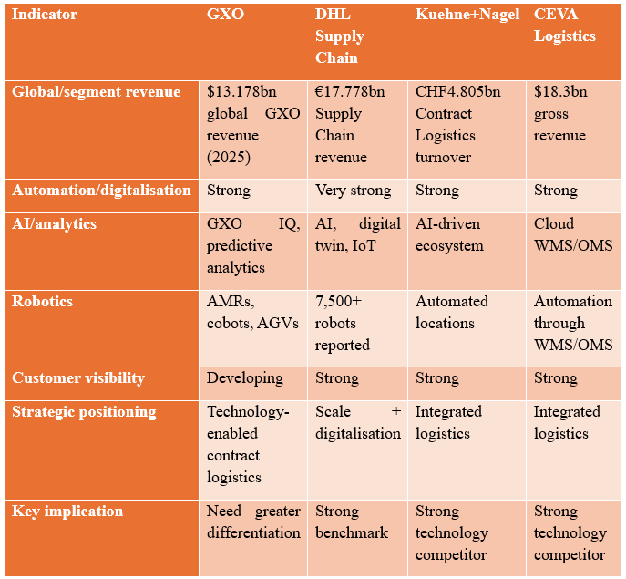

Appendix F – Evidence Triangulation Matrix


